Question 1:

Define Object Oriented Programming Language?

**OBJECT ORIENTED PROGRAMMING LANGUAGE:**

**As the name suggests, Object-Oriented Programming or OOPs refers to languages that uses objects in programming. Object-oriented programming aims to implement real-world entities like inheritance, hiding, polymorphism etc in programming. The main aim of OOP is to bind together the data and the functions that operate on them so that no other part of the code can access this data except that function.**

**Question 2:**

**List down the Benefits of OOP?**

**BENEFITS OF OOP:**

* **It provides a clear modular structure for programs which makes it good for defining abstract datatypes in which implementation details are hidden**
* **Objects can also be reused within an across applications. The reuse of software also lowers the cost of development. More effort is put into the object-oriented analysis and design, which lowers the overall cost of development.**
* **It makes software easier to maintain. Since the design is modular, part of the system can be updated in case of issues without a need to make large-scale changes**
* **Reuse also enables faster development. Object-oriented programming languages come with rich libraries of objects, and code developed during projects is also reusable in future projects.**
* **It provides a good framework for code libraries where the supplied software components can be easily adapted and modified by the programmer. This is particularly useful for developing graphical user interfaces.**
* **Better Productivity as OOP techniques enforce rules on a programmer that, in the long run, help her get more work done; finished programs work better, have more features and are easier to read and maintain. OOP programmers take new and existing software objects and "stitch" them together to make new programs. Because object libraries contain many useful functions, software developers don't have to reinvent the wheel as often; more of their time goes into making the new program.**

**Question 3:**

**Differentiate between function and method?**

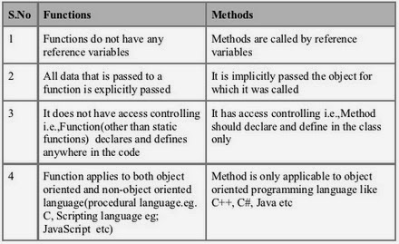

**Question 4:**

**Define the following terms:**

1. **Class**
2. **Object**
3. **Attribute**
4. **Behavior**

**CLASS:**

**A class is a blueprint for creating objects (a particular data structure), providing initial values for state (member variables or attributes), and implementations of behavior (member functions or methods).**

**The user-defined objects are created using the class keyword. The class is a blueprint that defines a nature of a future object. An instance is a specific object created from a particular class. Classes are used to create and manage new objects and support inheritance—a key ingredient in object-oriented programming and a mechanism of reusing code.**

**OBJECT:**

**objects are the things you think about first in designing a program and they are also the units of code that are eventually derived from the process. In between, each object is made into a generic**[**class**](https://whatis.techtarget.com/definition/class)**of object and even more generic classes are defined so that objects can share models and reuse the class definitions in their code. Each object is an instance of a particular class or subclass with the class's own methods or procedures and data variables. An object is what actually runs in the computer.**

**ATTRIBUTE:**

**In Object-oriented programming(OOP), classes and objects have attributes. Attributes are data stored inside a class or instance and represent the state or quality of the class or instance. In short, attributes store information about the instance. Also, attributes should not be confused with class functions also known as methods. One can think of attributes as noun or adjective, while methods are the verb of the class.**

**BEHAVIOR:**

**A class's behavior determines how an instance of that class operates; for example, how it will "react" if asked to do something by another class or object or if its internal state changes. Behavior is the only way objects can do anything to themselves or have anything done to them.**

**Question 5:**

**Write a code in python in which create a class named it Car which have 5 attributes such like (model, color and name etc.) and 3 methods. And create 5 object instances from that class.**

**CODE:**

